Tasks Completed So Far

- Selected Chair Sit-and-Reach Test as the first flexibility test to implement.
- Chose Python as the development language due to its ease of use and rich ecosystem.
- Set up the software environment using:
- mediapipe, opencv-python, and numpy for pose detection and visualization.
- Logitech webcam as the primary hardware (compatible with built-in webcams as well).
- Decided to use Jupyter Notebook over Google Colab, since Colab does not support real-time webcam input.

High level block diagram for Chair Sit-and-Reach Test.
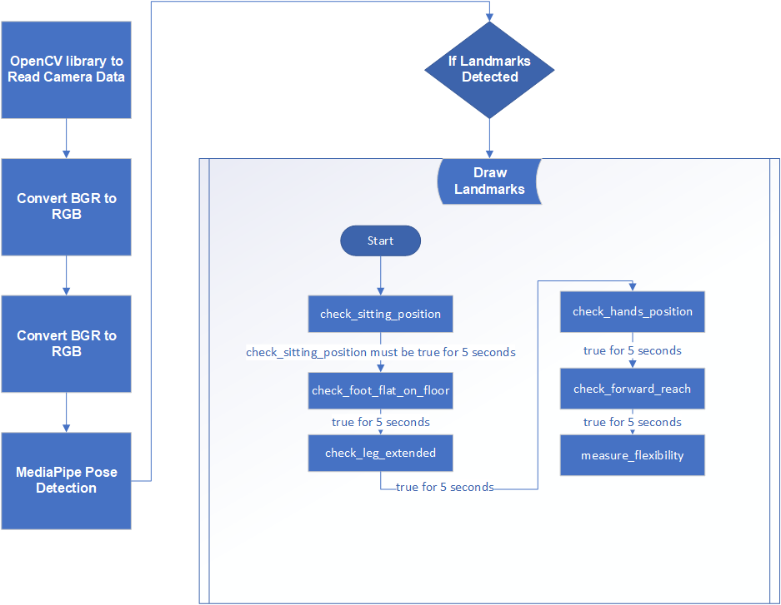

Currently Working On
- Environment Setup: install mediapipe, opencv-python, and numpy.
- Import necessary libraries: cv2, mediapipe, numpy, math, enum, and time.
- MediaPipe Pose Initialization: initialize MediaPipe's Pose model with a confidence threshold.
- Debug Landmark Printing: create a debug_print_landmarks function to display the coordinates and visibility of key body landmarks, which is very helpful for understanding the pose detection.
- TestState Enum: define an Enum to manage the different stages of the flexibility test, providing a clear structure for your state machine.
- FlexibilityTest Class:
- Initialized with current_state, state_passed, hold_timer, hold_start_time, measurement_result, debug_enabled, and advance attributes.
- get_state_message(): Provides instructional messages for each test state.
- advance_state(): Logic to transition between test states sequentially.
- reset_test(): Function to reset the test to its initial state.
- check_sitting_position Function: implement a basic check for the sitting position by comparing the average Y-coordinates of hips and knees.
- Placeholder Functions: create placeholder functions for other checks (check_foot_flat_on_floor, check_leg_extended, check_hands_position, check_inhale, check_forward_reach, measure_flexibility).
- Main Execution Loop (main() function):
- Initializes the camera.
- Creates an instance of FlexibilityTest.
- Processes video frames using MediaPipe.
- Draws landmarks on the frame.
- State Machine Logic: The core if/elif structure for transitioning through TestState is in place, calling the respective check functions.
- Hold Position Logic: Basic timer for the HOLD_POSITION state.
- Text Overlay: Displays the current instruction message and status message on the video feed.
- Auto-Advancement Logic: add a 5-second delay for state advancement (if time.time() - start_time > 5:), which seems to be a general timer to move to the next step if the current one is "passed".
- User Controls: Implement 'q' to quit, 'd' for debug, and 'r' to reset.
- Displays the processed frame.

Planned Tasks for Upcoming Weeks

Implement/Complete Placeholder Functions: (check_foot_flat_on_floor, check_leg_extended, check_hands_position, check_inhale, check_forward_reach, measure_flexibility).

